1. Simple linear regression:
2. Fast Charge vs Range:

|  |  |
| --- | --- |
| Y_Test | Y_Pred |
| 350  420  400  170  95  330  375  190  450  160  420  340  390  450  275  280  290  435  750  310  195 | 362.88  367.184  418.834  233.755  151.976  276.796  487.701  233.755  362.88  151.976  393.009  354.272  349.967  431.747  332.751  345.663  250.971  543.655  457.572  431.747  225.146 |

Score: R2 = 0.569

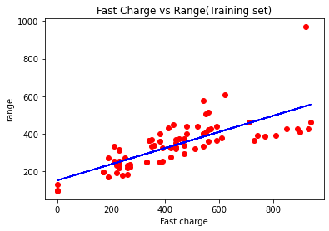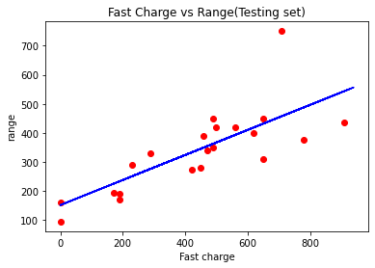

1. Efficiency Vs Range:

|  |  |
| --- | --- |
| Y_Test | Y_Pred |
| 350  420  400  170  95  330  375  190  450  160  420  340  390  450  275  280  290  435  750  310  195 | 313.205  361.991  331.053  315.584  325.104  440.525  381.029  353.661  366.75  346.522  333.433  319.154  406.017  327.484  310.825  390.549  328.673  314.395  433.385  297.736  313.205 |

Score: R2 = 0.097

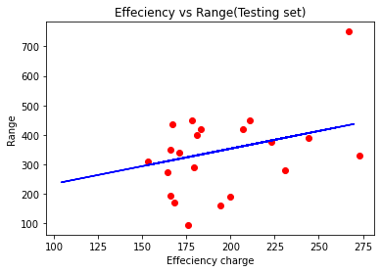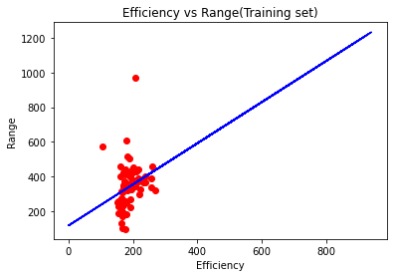

1. Efficiency Vs Range:

|  |  |
| --- | --- |
| Y_Test | Y_Pred |
| 350  420  400  170  95  330  375  190  450  160  420  340  390  450  275  280  290  435  750  310  195 | 312.264  429.823  381.178  192.678  144.843  441.985  416.446  231.189  441.985  202.812  389.286  312.264  462.254  401.447  259.565  389.286  287.942  360.909  887.899  279.834  226.324 |

Score: R2 = 0.826

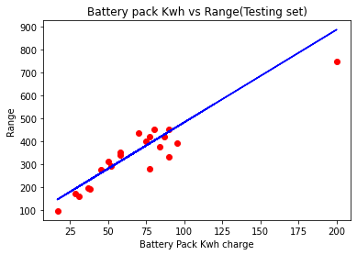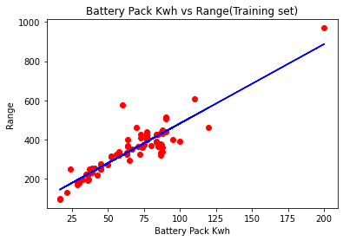

1. Top Speed vs Range:

|  |  |
| --- | --- |
| Y_Test | Y_Pred |
| 350  420  400  170  95  330  375  190  450  160  420  340  390  450  275  280  290  435  750  310  195 | 297.149  385.012  406.978  264.201  231.252  253.218  516.806  215.876  494.841  231.252  297.149  297.149  363.046  385.012  275.184  363.046  297.149  519.003  406.978  439.926  231.252 |

Score: R2 = 0.559

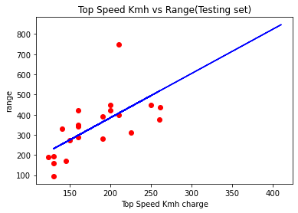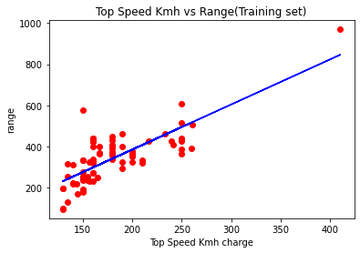

1. Accel Sec vs Range:

|  |  |
| --- | --- |
| Y_Test | Y_Pred |
| 350  420  400  170  95  330  375  190  450  160  420  340  390  450  275  280  290  435  750  310  195 | 362.88  367.184  418.834  233.755  151.976  276.796  487.701  233.755  362.88  151.976  393.009  354.272  349.967  431.747  332.751  345.663  250.971  543.655  457.572  431.747  225.146 |

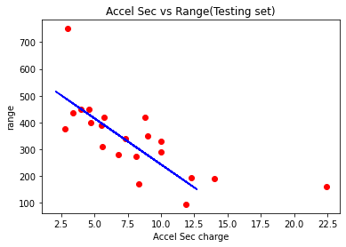Score: R2 = 0.436

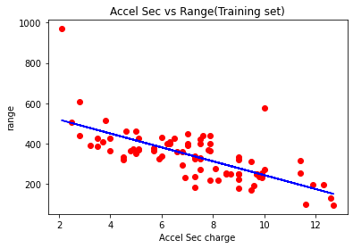

1. Price Euro vs Range

|  |  |
| --- | --- |
| Y_Test | Y_Pred |
| 350  420  400  170  95  330  375  190  450  160  420  340  390  450  275  280  290  435  750  310  195 | 362.88  367.184  418.834  233.755  151.976  276.796  487.701  233.755  362.88  151.976  393.009  354.272  349.967  431.747  332.751  345.663  250.971  543.655  457.572  431.747  225.146 |

Score: 0.455

